GGL System report

(<http://ggl.neotural.com/login>)

1. Admin – Approval booking – Please for information Approval Booking adjusted by information booking details (sort by category)

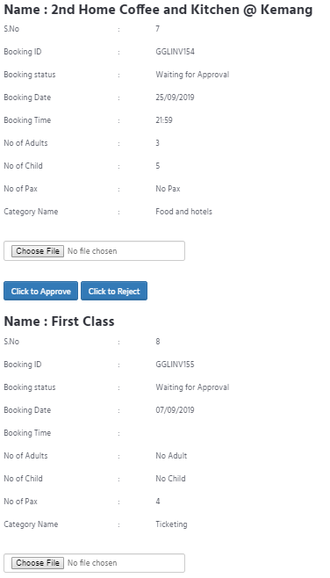

2. [www.gglway.com](http://www.gglway.com) – Contact – Please add for receive an any Message in GGL to email : globalgains49@gmail.com - cannot click send

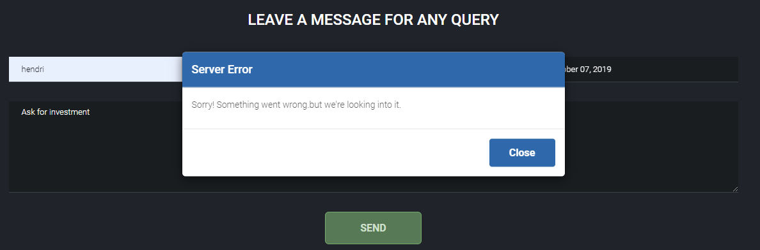

3. Member – Email – Not get email notification if Unit Status is Close - Please add for member and admin (admin must know if Status is Close)

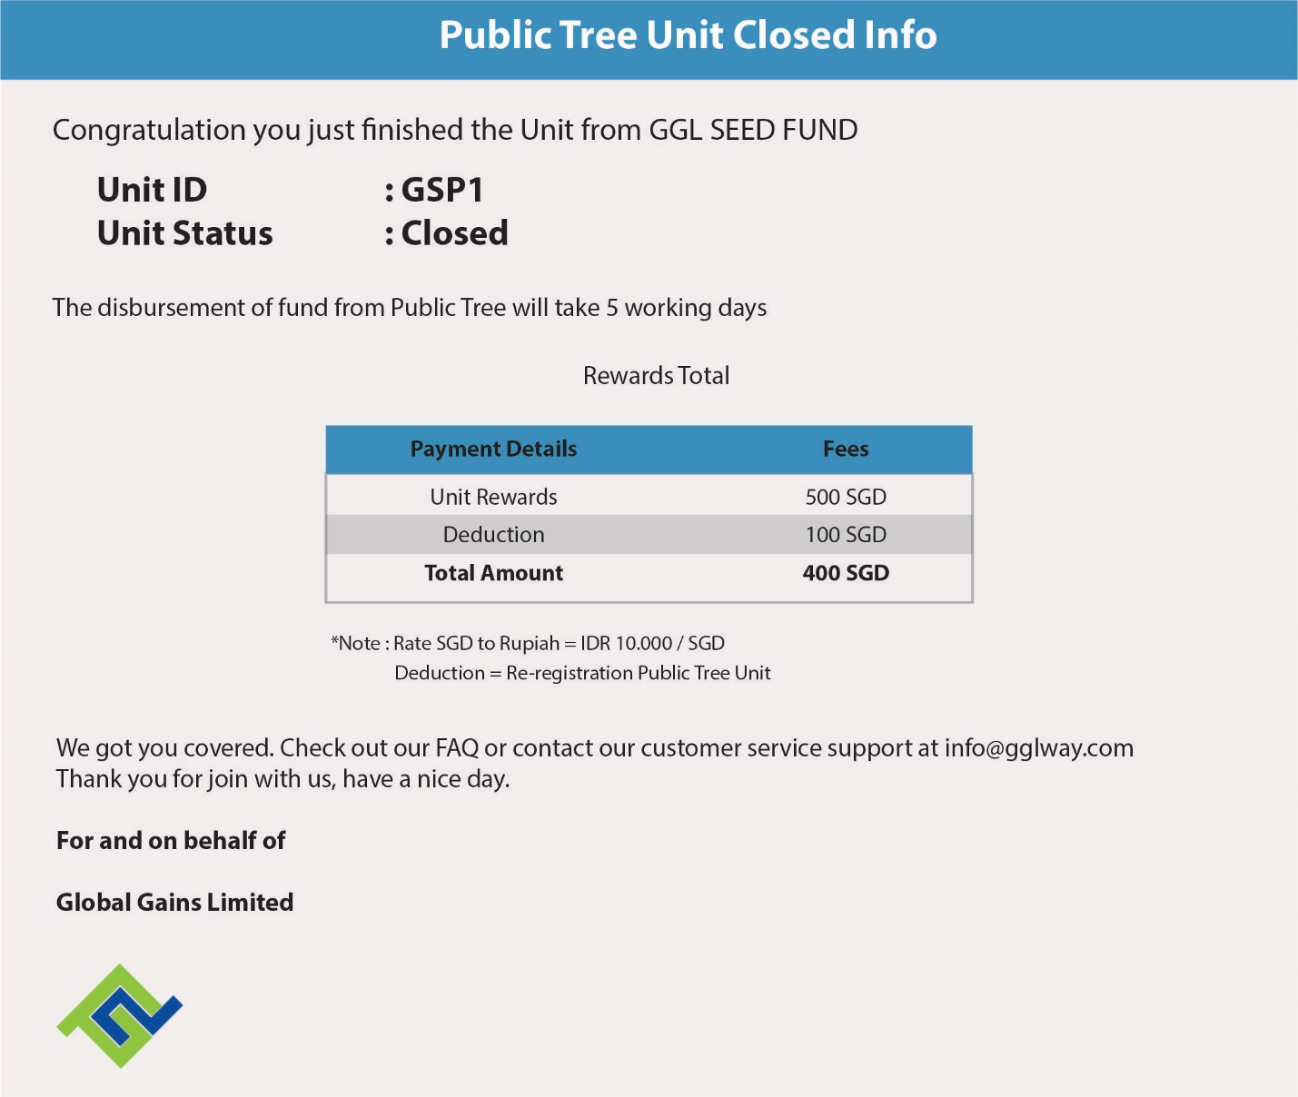

4. Email - Member – Investment – Purchase Unit – Notification Invoice on email (please change like this picture) - *note : please adjust member name, invoice number, and total amount on invoice

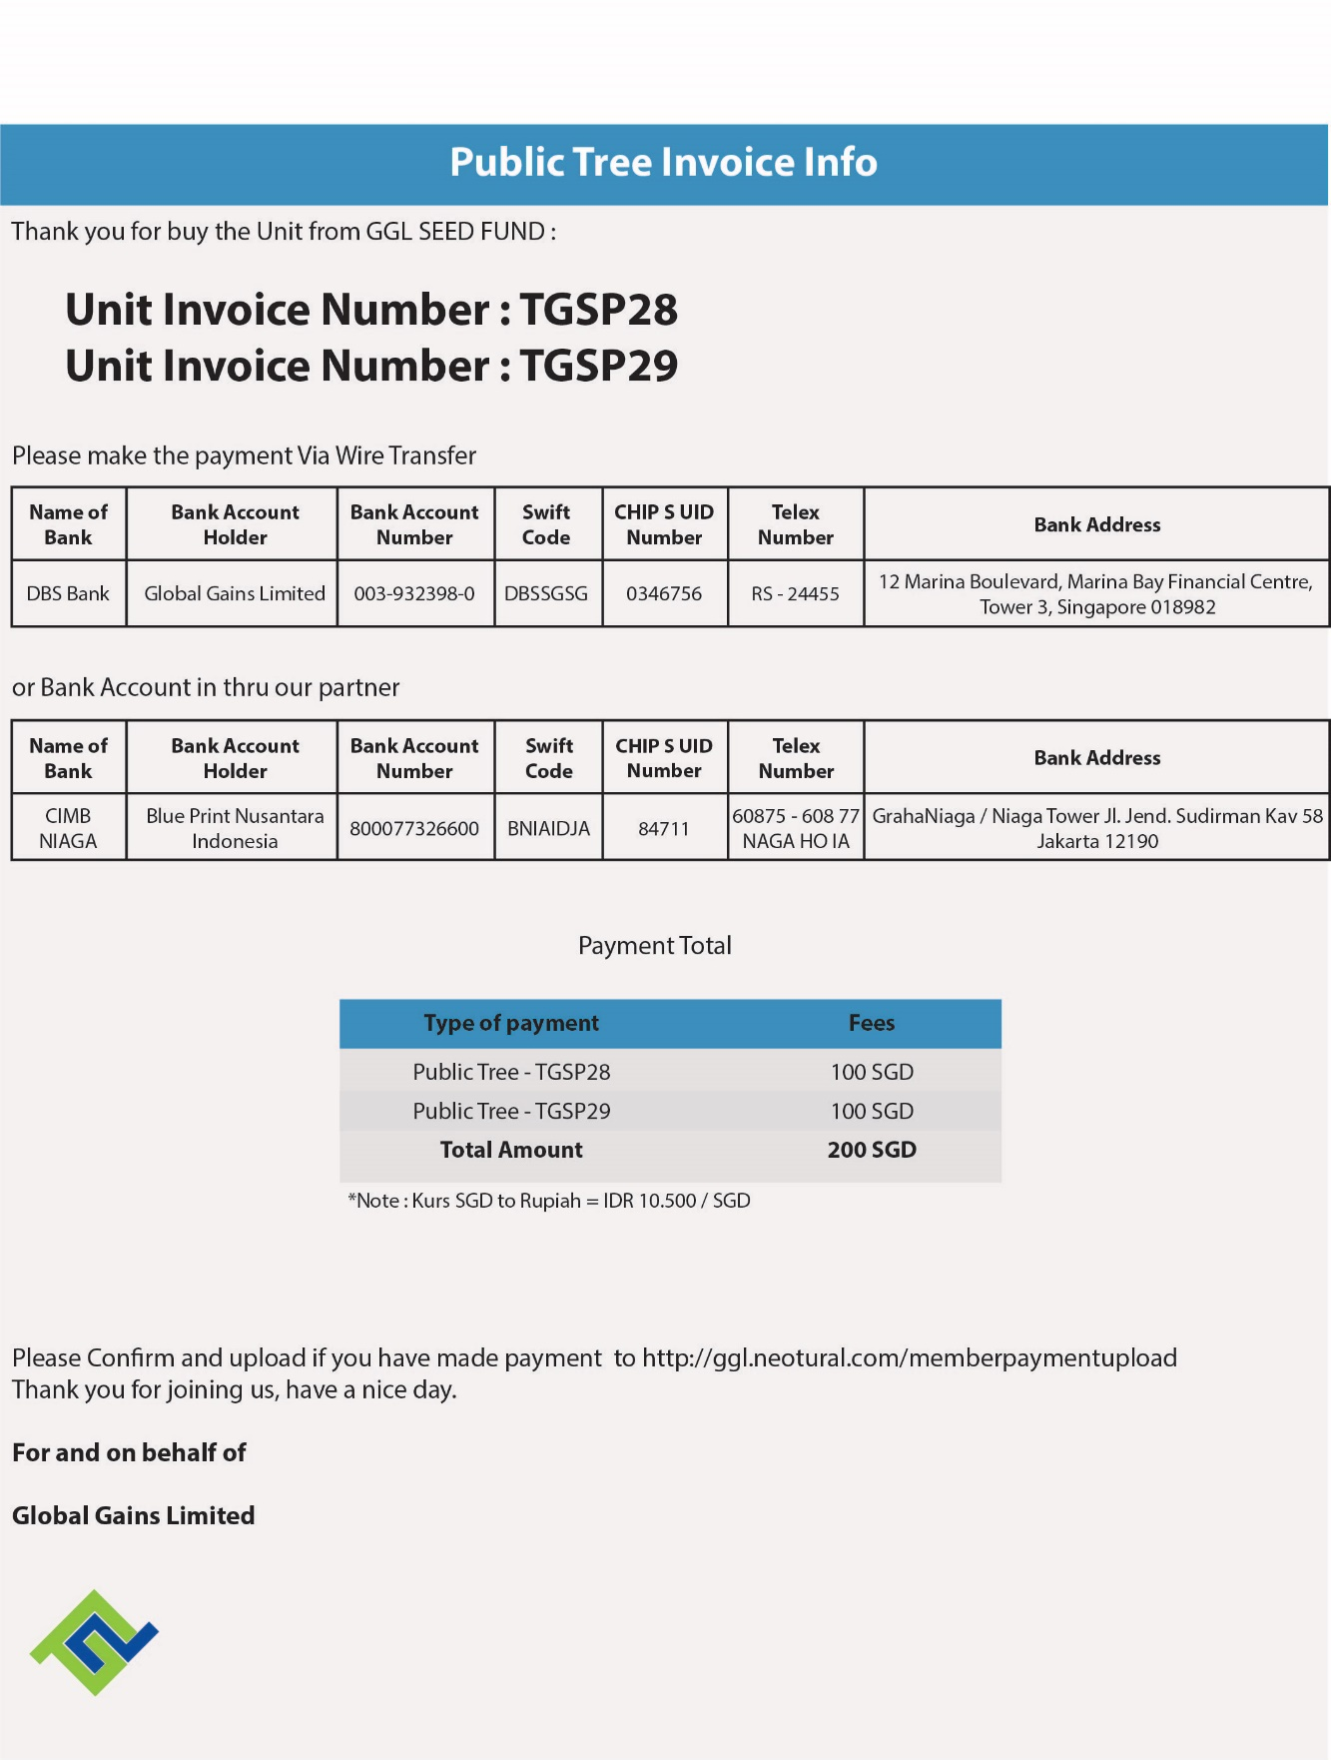

12. Member – Registration – Success – Check Email (not get email)

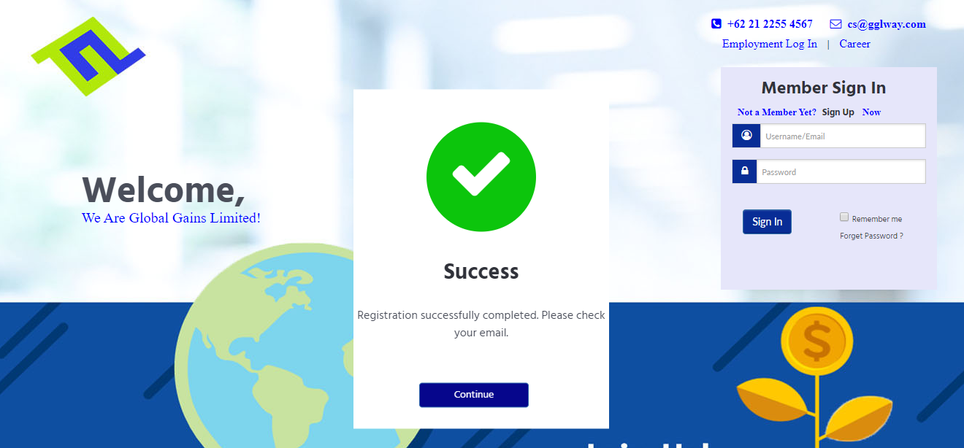

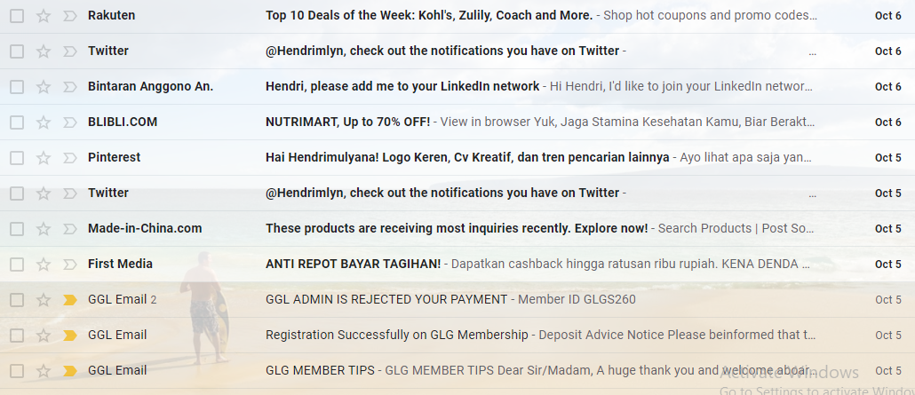

11. Member - booking tools – Please change linked to page booking existing (not booking history)

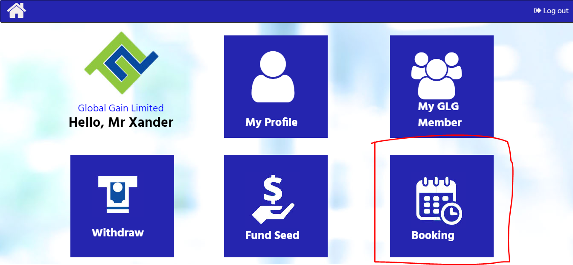

12. Member – Withdraw – Please add Report (History) Commission and Overriding for member – Change Withdraw Amount can be input Manual

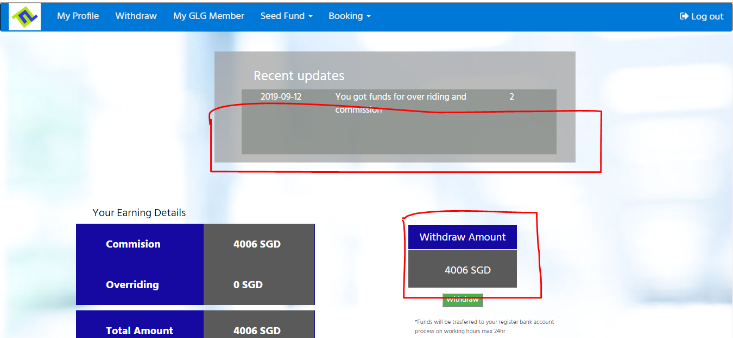

13. New UI for Booking Tools will be send from Paulus Kurnia

14. Please add Blueprint Nusantara Account Number For Wire transfer on FUND SEED, new design will be send from Paulus

15. Member – Fund Seed – Purchase Unit – Please Add New Tree the name is “ MINI TREE” ( every 3 user come in, 1 user will be out. 1 user will get 100 SGD as payment and another 100 SGD join back, Commission 50% from member fee)

GGL Mobile Apps report

1. Member – Withdrawl – Cannot Click Withdrawl

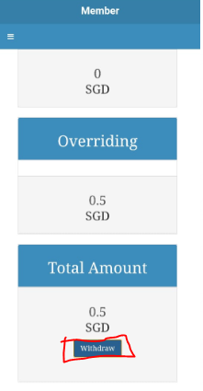

2. Member – Investment – Please change name INVESTMENT to FUND SEED

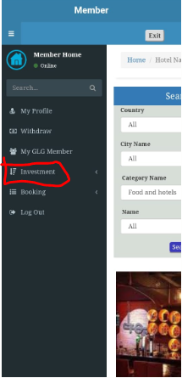

3. New UI for Mobile App Please adjust by website UI